**Direction on how to run the inference code**

**Part 1**

Open the file “part1_inference_code.py”

1. input a directory of WAV audio files ‘here’

llke eval_volume_path = “directory of WAV audio files”

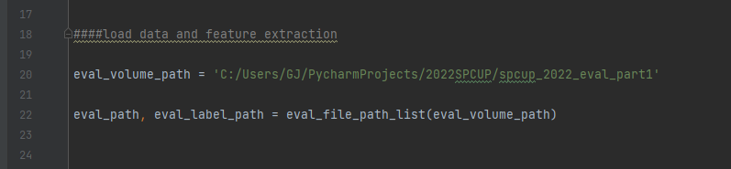

**Get the result for part 1 evaluation set**

the above code saves CSV files for test data sets tha named “answer_part1.csv”

The path where the “answer_part1.csv” file is stored is the same as the directory where the file “part1_inference_code.py " is located.

**Part 2**

Open the file “part2_inference_code.py”

1. input a directory of WAV audio files ‘here’

llke eval_volume_path = “directory of WAV audio files”

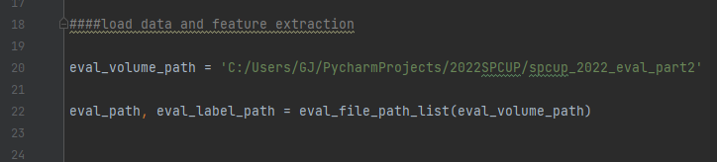

**Get the result for part 2 evaluation set**

the above code saves CSV files for test data sets tha named “answer_part2.csv”

The path where the “answer_part2.csv” file is stored is the same as the directory where the file “part2_inference_code.py " is located.